Bahria University,

Karachi Campus

LAB EXPERIMENT NO.

10

LIST OF TASKS

|  |  |
| --- | --- |
| TASK NO | OBJECTIVE |
| **01** | An automotive company wants to identify and treat outliers in their "mtcars" dataset. which contains information about various car models. They suspect that certain car models might have outlier values in certain variables and want to analyze and handle them using Python. |
| **02** | An automotive company has identified outliers in their "mtcars" dataset and wants to treat them to ensure accurate analysis and modeling. They want to detect and handle the outliers using Python. Performed the techniques that provided in the lab to treat the outliers. |
|  |  |

Submitted On:

08-05-2024

(Date: DD/MM/YYYY)

**Task No. 01:** An automotive company wants to identify and treat outliers in their "mtcars" dataset. which contains information about various car models. They suspect that certain car models might have outlier values in certain variables and want to analyze and handle them using Python.

Perform the following outlier detection techniques.

* Box Plot
* Z-score
* IQR range
* Scatter

**Solution:**

import pandas as pd

import numpy as np

import matplotlib.pyplot as plt

import seaborn as sns

from scipy import stats

df = pd.read_csv('mtcars.csv')

# Display the first few rows

df.head()

**Box Plot**

plt.figure(figsize=(12, 8))

df.boxplot()

plt.title('Box Plot for all numeric columns in mtcars dataset')

plt.show()

# Box plot for a specific column (e.g., 'mpg')

plt.figure(figsize=(8, 6))

sns.boxplot(x=df['mpg'])

plt.title('Box Plot for mpg')

plt.show()

**Z-score**

# Calculate Z-scores

z_scores = np.abs(stats.zscore(df.select_dtypes(include=[np.number])))

# Define a threshold for identifying outliers

threshold = 3

# Identify outliers

outliers = np.where(z_scores > threshold)

outlier_rows = np.unique(outliers[0])

print(f"Rows with outliers based on Z-score:\n{df.iloc[outlier_rows]}")

# Remove outliers based on Z-score

df_no_outliers = df[(z_scores < threshold).all(axis=1)]

print(f"Data without outliers based on Z-score:\n{df_no_outliers}")

# Verify removal

plt.figure(figsize=(12, 8))

df_no_outliers.boxplot()

plt.title('Box Plot for all numeric columns in mtcars dataset (Outliers removed)')

plt.show()

**IQR range**

def find_outliers_iqr(data):

Q1 = data.quantile(0.25)

Q3 = data.quantile(0.75)

IQR = Q3 - Q1

outliers = (data < (Q1 - 1.5 * IQR)) | (data > (Q3 + 1.5 * IQR))

return outliers

numeric_cols = df.select_dtypes(include=[np.number])

outliers_iqr = numeric_cols.apply(find_outliers_iqr)

outlier_rows_iqr = df[outliers_iqr.any(axis=1)]

print(f"Rows with outliers based on IQR:\n{outlier_rows_iqr}")

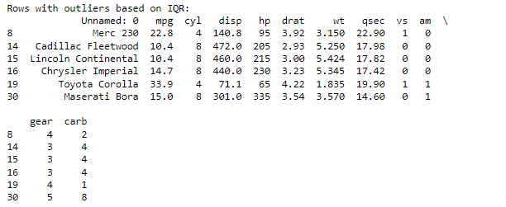

**Scatter**

# Scatter plot for mpg vs. hp (Horsepower)

plt.figure(figsize=(10, 6))

sns.scatterplot(x=df['hp'], y=df['mpg'])

plt.title('Scatter Plot of hp vs mpg')

plt.xlabel('Horsepower (hp)')

plt.ylabel('Miles per Gallon (mpg)')

plt.show()

# Scatter plot for mpg vs. wt (Weight)

plt.figure(figsize=(10, 6))

sns.scatterplot(x=df['wt'], y=df['mpg'])

plt.title('Scatter Plot of wt vs mpg')

plt.xlabel('Weight (wt)')

plt.ylabel('Miles per Gallon (mpg)')

plt.show()

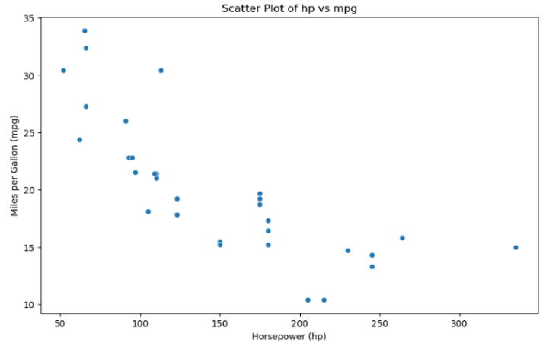

**Task No. 02:** An automotive company has identified outliers in their "mtcars" dataset and wants to treat them to ensure accurate analysis and modeling. They want to detect and handle the outliers using Python. Performed the techniques that provided in the lab to treat the outliers.

**Solution:**